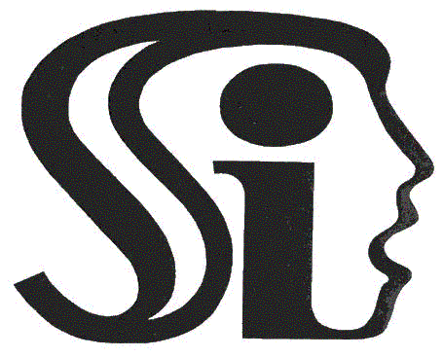

Skálův institut
Prague, Czech Republic

It is our pleasure to invite you to participate in the
2nd International conference on integrative psychotherapy
Contemporary integrative psychotherapy
The conference will be held 22-23. 6. 2016
Emmaus Monastery, Prague 2, Vyšehradská 49/320

Pre-conference one day workshop - 21. 6. 2016
TLDP – Time-limited dynamic psychotherapy
Hanna Levenson – SEPI – Society for the Exploration of Psychotherapy Integration

Please fill out the registration form and send it to the email address: skaluvinstitut@seznam.cz.

A. Registration form
Title:
Surname: |  |  | Name:
Profession:
Institution/Hospital/Organization:
Dept.: |  | Position:
Address:
City: |  | Country:
Tel: |  | Fax:
Mobile:
E-Mail:
 | B. Registration fees (mark with X) – first day English presentations and pre-conference workshop will be translated from English to Czech language, the other parts will be held in Czech language

 | Czech Republic | Foreigners
Active participants | 500 Czech crowns | 20 EUROS
Passive participants | 2000 CZ | 80 Euros
Pre-conference workshop | 2500 CZ | 100 Euros

Some other useful contacts and informations:
www.skaluvinstitut.cz
facebook: integrativní psychoterapie
PhDr. Magdalena Frouzová – chairman
– magdalena.frouzova@cmail.cz; +420 602 642 616
Bank account:
- Swift code: KOMBCZPPXXX
- IBAN – CZ5501000000191497540217

Place of the conference: Emmaus Monastery
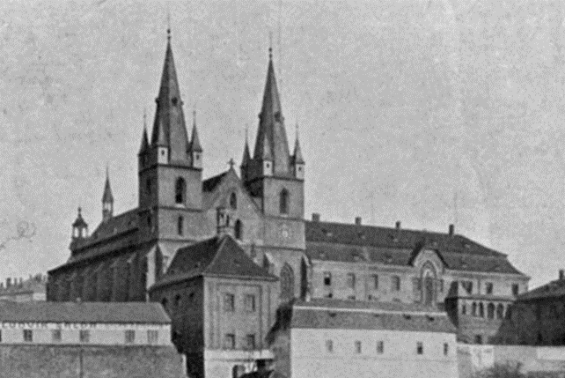
Monastery at the end of the 19th century
The Emmaus monastery (Czech: Emauzy or Emauzský klášter) is an abbey established in 1347 in Prague. The area became the only Benedictine monastery of the Bohemian kingdom and all Slavic Europe.

In the 1360s, the Cloisters of the Monastery were decorated with a cycle of 85 wall Gothic paintings with parallels from the Old and New Testaments. The Gothic cloisters also feature original faded frescoes with bits of Pagan symbolism from the 14th century. The monastery was baroquized in the 17th-18th centuries and the two temple towers were added.

Charles IV gave to the just-founded monastery the manuscript Reims Gospel, it was probably lost from Prague in the time of the Hussite Wars, manuscript later became part of the Reims Cathedral treasury. The monastery became a center of culture and art, students of Cyril and Methodius studied there in addition to Jan Hus.

During WWII the monastery was seized by the Gestapo and the monks were sent to Dachau concentration camp. The monastery building and vaults were destroyed by a U.S. bombing raid on Prague on 14 February 1945.

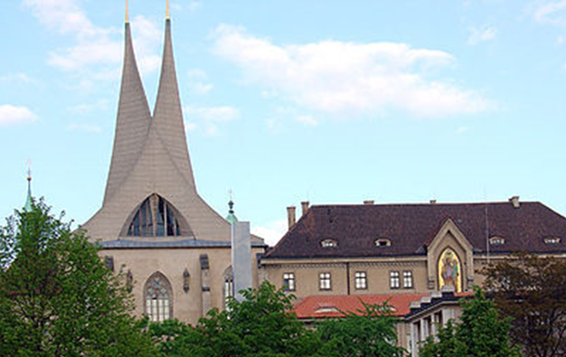

The modern roof with steeples was added in the 1960s. It was returned to the Benedictine order in 1990, the monastery currently belongs to three monks, two of whom live there.

Place of the workshop with Hanna Levenson:
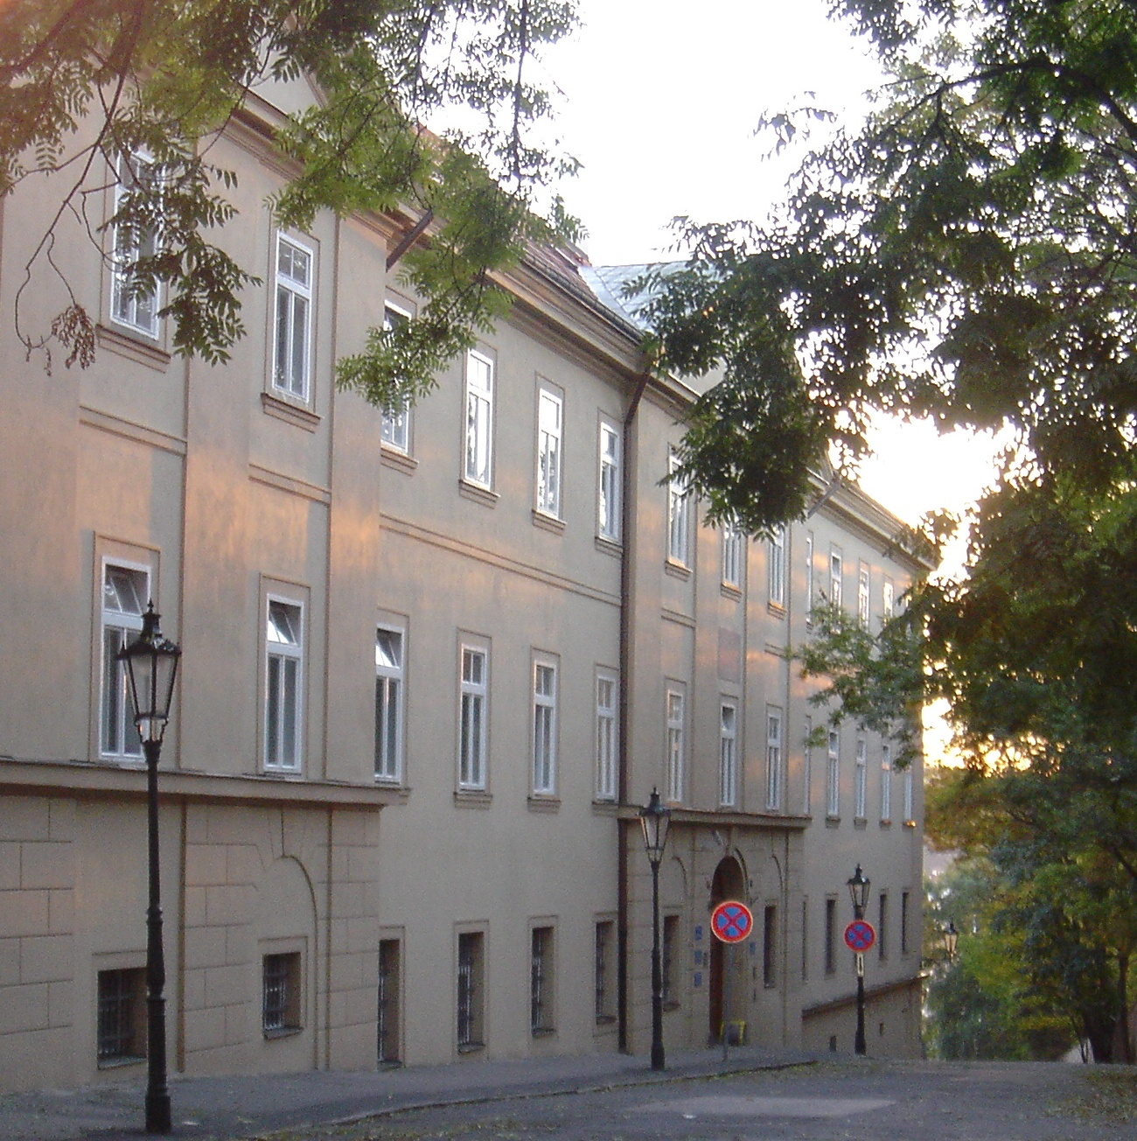
The first Czech Addiction Rehab Clinic - Apolinářská 4, Prague 2, 120 00- follows up the work of Dr.Jaroslav Skála, an addiction expert (from 1948) and the founder of the first sobering-up station (1951) as a health center facility in the world. The yearly number of patients is about one thousand. Another five thousand people ask for a consultation and some 500 are admitted to hospital due to alcohol or drug addiction. Statistics say that there are about 30 thousand people addicted to drugs and about a half a million people addicted to alcohol.

History of psychotherapy in Czechoslovakia regarding integrative approach.

Sigmund Freud was born in the region of the present-day Czech republic and moved to Vienna when he was three years old. He often recalled his Czech nanny, who was almost like a mother to him. He also experienced his first platonic love on his return here, when he was 16 years old. The group of psychoanalysis registered by International Psychoanalytical Association was founded between first and second world war and has been providing the training since. The most eminent specialist in the field of psychotherapy was Ferdinand Knobloch, who emigrated to Canada in 1968 and he is an author of the book Integrated Psychotherapy.
Dr. Stanislav Kratochvíl has published several books regarding psychotherapy during 40 years and he is a key figure regarding integrative approach.
SUR training system in group and community psychotherapy has been the main psychotherapy training system in Czechoslovakia from 1969. Its name is derived from the initial letters of the first names of its founders: Skála (a key figure of psychotherapeutic movement), Urban, Rubeš. The program has a good reputation and most Czech and Slovak psychotherapists have undergone it (about 2000 participants). The participants undergo through various psychotherapeutic techniques, which are developed into specialized conceptions according integrative movement.
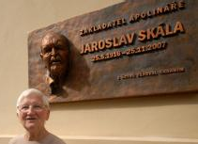
Dr. Skala and his partner A. Maťová

